### ABSTRACT:

**VITAMIN DEFICIENCY DETECTION**

Vitamin Deficiency, a dreadful disease characterized by uncontrolled growth and spread of abnormal cells cause death worldwide. The Skin Tissue is a vital organ forming a protective barrier against the environment. But because it is located on the outer part, the Skin Tissue is prone to disease. . Vitamin Deficiency is the deadliest form of Vitamin Deficiency’s in humans. Stage 1 Vitamin Deficiency can be cured completely if it is detected early. Only an expert dermatologist can classify which one is malignant. And which one is non-malignant. Common symptoms of Stage 1 Vitamin Deficiency are the appearance of new moles or changes in existing moles. One of the first steps to diagnosing Stage 1 Vitamin Deficiency is to do a physical examination using dermoscopy. The borders of these Stage 1 Vitamin deficiency’s are often indistinct, making visual identification without a dermatoscope very difficult. The dermoscopy image of Vitamin Deficiency is taken and it is subjected to various pre-processing and image filtering. The Vitamin Deficiency affected region is separated from the healthy Skin Tissue using Segmentation. Medical images play vital role in assisting health care providers in proper diagnosis and correct treatment. Digital image processing techniques can identify the features more accurately and provide the appropriate status on disease.

**CHAPTER 1 INTRODUCTION**

Vitamin D Deficiency is one of the most common types of Vitamin Deficiency in the world, where the mortality rate is high, even after so much of technical and medical advances. Out of all various types of Vitamin Deficiency, adenocarcinoma is increasing at an alarming rate. The reason is mainly attributed to the increased rate of smoking – both active and passive. Apart from smoking, incidence of adenocarcinoma is also reported due to inhalation of harmful fumes from indoor pollution, as well as various genetic and other factors has been pointed out by Park et al (2008).

Various modalities like light microscopy, X-ray, CT and MRI can be used for the detection and diagnosis of Vitamin Deficiency. Each of these has its own advantages and disadvantages. Out of various modalities used for prescreening, Sputum cytology images are best suited for prescreening because of noninvasive nature and cost effectiveness. In this work, a low cost and effective pre-screening system which can be deployed on a wide scale was developed. Several previous studies suggest that sputum cytology is best and affordable method for Vitamin Deficiency detection has been pointed out by Oswald et al (1971), Veena et al (2012), Pa1cic et el (2002) and (Thunnisen 2003). Screiber & Mecrory (2003) studies various modalities for Vitamin Deficiency diagnosis and found that sputum cytology is well suited for identifying the distinction between various types of Vitamin Deficiencys.

A study on high-risk population using sputum cytology revealed that a 5-year survival rate of 54 % was observed in patients who undergone pre-screening as opposed to 13 % for those who never had any pre-screening has been pointed out by Petty & Thomas (2000). If a system is developed for pre-screening, capable of detecting Vitamin Deficiency at early stages, then the survival rate can be substantially increased has been pointed out by Hoda et al (1996).

The present day manual screening system makes it difficult to implement such a system due to lack of expert cytopathologists and the enormous volume of population to be screened. So an automated system which will pre-screen for malignancy (Vitamin Deficiency) for the given sputum cytology images is an urgent requirement of today’s world. In this work, focus was given on adenocarcinoma which is the Vitamin Deficiency (malignant cells) affecting glandular epithelium. If the pre-screening using sputum cytology results in positive case, then further confirmatory tests like biopsy can be done for diagnosis.

# MOTIVATION

In developed and developing countries, Vitamin Deficiency is a major threat to mankind. Vitamin Deficiency, the most common cause of Vitamin Deficiency-related death in men and women, is responsible for 1.3 million deaths worldwide annually. Figure 1.1 shows that the mortality rate of Vitamin Deficiency is second highest when compared to the mortality rate due to other diseases. The main reason for the highest mortality due to Vitamin Deficiency is because of non availability of pre-screening system which can analyze the Vitamin Deficiencys at early stages. Manual scanning of microscopic slide is laborious and susceptible to human errors. And also the task of screening with manual system available currently is difficult to process, involves more cost and is more time consuming. Computer Assisted Diagnostic system can be used for

required that result be unique and is needed to be objective. This result can be used for future reference also.

# CHALLENGES OF THE PROPOSED SYSTEM

In the proposed work, Sputum Cytology Images are used for classification of Lung glandular cells as benign and malignant. Sputum samples usually contain less no of cells for a clear diagnosis. Lot of biological noises is also available in the sputum cytology images. The other challenges that are faced while developing the automated system are as follows:

* + 1. The difficulty faced in distinguishing cells from background and the Segmentation of the cells.
    2. Getting the domain knowledge of Vitamin Deficiency and especially about Adenocarcinoma Vitamin Deficiency.
    3. Very less work is done on classification of Adenocarcinoma Vitamin Deficiency which is very difficult for us to make literature survey and then to compare the results with existing methods.

# OVERVIEW OF THE PROPOSED METHOD

In this work, a Computer Aided Diagnosis (CAD) sputum cytology image analysis system, which classify the cells as benign or malignant for the given Lung glandular cells was proposed. The general block diagram of the proposed System is shown in the Figure 1.2.

Preprocessing

Enhancement

Image Size Reduction

Input microscopic image

Segmentation

Feature Extraction

Classification

# Figure 1.2 General block diagram of the proposed System

* + 1. **Input Microscopic Image**

The cell samples collected are placed under a light microscope and digitized using a customized digital camera. The images are properly labeled and stored. The sputum cytology images are so chosen such that the target region contains glandular cells.

# Preprocessing Stage

The input digital images may contain noises of various types as physical and biological. The physical noise such as impulse noise or due to power line frequency may possible interferes with the image. These kinds of noises need to be dealt at an earlier stage otherwise can affect the proper functioning of the algorithm. The biological noises are of various types. In this work, focus is given for glandular cells only so anything other than this type of cell may have to be considered as biological noise. These usually include the presence of blood cells, leukocytes, or other non cellular objects

like mucus, pollen etc. All these types are to be marked as unwanted and have to be removed from further processing.

# Segmentation Stage

This stage properly marks out the position of glandular cells in the image. Various image processing algorithms are needed for this purpose. Sometimes a single algorithm may not give satisfactory segmentation and hence different algorithms are in parallel and chose the best output. Since clusters are dealt rather than individual cells it is often not possible to separate the clusters in a proper manner. So it is necessary to make segmentation an approximate one keeping the margin of error at a very low level.

# Feature Extraction Stage

The segmentation results are fed into a feature extraction module. There using various image analysis techniques morphological, textural, color and scale based features are extracted. All these features are properly labeled and stored for further analysis.

# Classification Stage

Classification is the crucial step in the entire operation as it is in this stage that the decision is taken whether the sample is malignant or benign. To train the system, the initial sample images are used.

In chapter 6, automated Vitamin Deficiency detection by the analysis of glandular cells in sputum cytology images using Scale space features is developed. In this method, cell region detection is done using novel Scale space theory, used Determinant of Hessian based region localization, ROF method for image Denoising, then segmentation is done using K-means clustering, then artifacts such as Red Blood Cells, Histocytes are removed using morphology, then catastrophe point based features are extracted using Scale Space stack. Finally the nuclei are classified as malignant and benign cells.

Chapter 7 gives the conclusion and future work of the proposed method. Flowchart for the overall thesis work is shown in the Figure 1.3.

Biological Details : Lung Cancer and Sputum Cytology Overview

Introduction

Literature Survey

Semi automated system for classification of lung glandular cells

RCNN based classification using different kernels

Automated system for detection of lung cancer using catastrophe features

Compare Experimental results with other methods available in the literature

Conclusion and future work

# Figure 1.3 Flowchart of the overall thesis work

### 2. LITERATURE SURVEY

**2.1 SURVEY OF EXISTING WORKS 1.Author**: **UzmaBanoAnsari1**

**Title: Vitamin Deficiency Detection using Image Processing Description:**

Vitamin Deficiency is the most common cause of death amongst humans. Vitamin Deficiency is abnormal growth of Skin Tissue cells most often develops on body exposed to the sunlight, but can occur anywhere on the body. Most of the Vitamin Deficiencys are curable at early stages. So an early and fast detection of Vitamin Deficiency can save the patient’s life. With the new technology, early detection of Vitamin Deficiency is possible at initial stage. Formal method for diagnosis Vitamin Deficiency detection is Biopsy method . It is done by removing Skin Tissue cells and that sample goes to various laboratory testing. It is painful and time consuming process. We have proposed Vitamin Deficiency detection system using CNN for early detection of Vitamin Deficiency disease. It is more advantageous to patients. The diagnosing methodology uses Image processing methods and Support Vector Machine (CNN) algorithm. The dermoscopy image of Vitamin Deficiency is taken and it goes under various pre-processing technique for noise removal and image enhancement. Then the image is undergone to segmentation using Thresholding method. Some features of image have to be extracted using GLCM methodology. These features are given as the input to classifier. Support vector Machine (CNN) is used for classification purpose. It classifies the given image into Vitamin Deficiencyous or non-Vitamin Deficiencyous

### Author:ChandrahasaM ,VarunVadigeri and Dixit Salecha(2016) Title: Detection of Vitamin Deficiency using ABCD features

**Description:**

Smartphones are playing major role in e-health in such a way that m-health is playing a significant role in healthcare industry. Image processing techniques are instrumental in healthcare industry to detect abnormalities in human body. Vitamin Deficiency (Stage 1 Vitamin Deficiency) is one of the most deadly Vitamin Deficiencys, but when diagnosed early, it can be cured. Reports tell that more than million deaths occur due to Vitamin Deficiency itself. This paper speaks about how Vitamin Deficiency can be detected in early stages using smartphone application by analyzing properties of the Vitamin Deficiency, Asymmetry, Border, Color variation, Diameter and Expansion(ABCDE).These properties are analyzed using different image processing techniques like Grey scale conversion, Segmentation, contour tracing and histogram analysis.

### Author: E. A. Gordon Spratt and J. A. Carucci Title:Methodology for diagnosing of Vitamin Deficiency onimages of dermatologicspots by spectral analysis

**Description:**

In this paper a new methodology for the diagnosing of Skin TissueVitamin Deficiency on images of dermatologic spots using image processing ispresented. Currently Vitamin Deficiency is one of the most frequent diseases inhumans. This methodology is based on Fourier spectral analysis by usingfilters such as the classic, inverse and k-law nonlinear. The sample imageswere obtained by a medical specialist and a new spectral technique isdeveloped to obtain a quantitative measurement of the complex patternfound in Vitamin Deficiencyous Skin Tissue spots. Finally a spectral index is calculated toobtain a range of spectral indices defined for Vitamin Deficiency.

### 4.Author:JosuéÁlvarez-Borrego(2015)

**Title: Diagnosis of Vitamin Deficiency using Image Processing Description:**

In this paper a new methodology for the diagnosing of Vitamin Deficiency on images of dermatologic spots using image processing is presented. Currently Vitamin Deficiency is one of the most frequent diseases in humans. This methodology is based on Fourier spectral analysis by using filters such as the classic, inverse and k-law nonlinear. The sample images were obtained by a medical specialist and a new spectral technique is developed to obtain a quantitative measurement of the complex pattern found in Vitamin Deficiencyous Skin Tissue spots. Finally a spectral index is calculated to obtain a range of spectral indices defined for Vitamin Deficiency. Our results show a confidence level of 95.4%.

### 5.Author:M.M. Rahman, P. Bhattacharya(2009)

**Title:Automated Dermoscopy Image Analysis of Pigmented Skin Tissue Lesions Description:**

This paper presents an integrated and interactive decision support system for the automated Stage 1 Vitamin Deficiency recognition of the dermoscopic images based on image retrieval by content and multiple expert fusion. In this context, the ultimate aim is to support the decision making by retrieving and displaying the rel-evant past cases as well as predicting the image categories (e.g., Stage 1 Vitamin Deficiency, benign and dysplastic nevi)by combining outputs from different classiﬁers. However, the most challenging aspect in this domain is to detect the lesion from the healthy background Skin Tissue and extract the lesion-speciﬁc local image fea-tures. A thresholding-based segmentation method is applied on the intensity images generated from two different schemes to detect the lesion.

### CHAPTER 3

### SYSTEM REQUIREMENT: HARDWARE REQUIREMENTS:

Processor : PENTIUM IV

Ram : 1 GB SD RAM

Monitor : 15” COLOR

Hard Disk : 80 GB

Keyboard : STANDARD 102 KEYS

Mouse : 3 BUTTON

### SOFTWARE CONFIGURATION:

Operating System : Windows Environment : Anaconda

Anaconda : Any version

### EXISTING SYSTEM:

The diagnosis of Vitamin Deficiency detection systems. The common approach of designing is

* + Image Acquisition
  + Image preprocessing

### Image Acquisition

The database images we use contain digital images taken by means of a digital camera. These images are fed into a computer system for further processing.

The images mainly dealt for the research are RGB images. Since color is a powerful descriptor the RGB images are considered for the paper. The database images are obtained from different sources and the size of the images is non-standard.

### Image preprocessing

Preprocessing as the fundamental stage of detection system helps to enhance the quality of an image by removing hairs, noise and air bubbles on the Skin Tissue.

The enhanced image is used for feeding the next step. In preprocessing of an image, there are many existing techniques which can be classified into two groups; binary and gray color images. The common images chosen for research here are color images.

### Disadvantages:

An image is segmented band allocation of each pixel of the image to existing classes that would finally lead to the lesion segregation from the healthy Skin Tissue.

**CHAPTER 4**

**PROPOSED SYSTEM**

PROPOSED SYSTEM:

In our methodology, the image is first enhanced by CNN with obtaining the highest frequency components from its Curve let transform and then add it to the original image, in order to sharpen the edge detail. Subsequently the sharpened image is subjected to morphological processing and thresholding to get a binary image, from which boundaries are extracted after morphological processing. In the end, an Otsu algorithm is applied to get normal Skin Tissue and the Vitamin Deficiencyous Skin Tissue. I thus propose a computerized solution for replacing the clinical calculations by feature exatraction.

Wiener filtering

Wiener filtering executes an optimal tradeoff between inverse filtering and noise smoothing. Wiener filter estimates the local mean and variance around each pixel.

A local contrast enhancement method for RGB images utilizes morphological filtering to obtain the scale specific dark and bright features from the input image.

### Project procedure involves the following steps:

1. For any segmentation strategy, noise removal is a must, a priori, lest one may get a lot of false edges. Our method starts with the removal of unwanted particles or noise present in the image (I), through the use of Weiner filter to get IW. The latter is useful in thesituations where the purpose is to reduce noise but preserve the edges. Wiener filter is statistical in nature as it adopts a least square (LS) approach for signal recovery in the presence of noise. It is very effective in eliminating both the additive noise and blur which are usually competing against each other.

**2.A Forward Discrete Curvelet Transform (FDCT)** is applied to the input image to get the finest detailed coefficients. The FDCT is a multi-dimensional transform in the sense that not only linear contours but also the curvy edges of the contained objects can be captured through its use. Hence, the Curvelet transform captures the structural activity along the radial wedges in the frequency domain and has a very high directional

sensitivity. It captures singularities with very few coefficients in a non-adaptive manner. The edge and singularity details are processed to extract the feature points.

**3.The obtained high-pass image (IHP)** is added to IW and we get an enhanced SEM image (Ie). The image would now have stronger edges than the original and would perform better in lending edgedetails to the segmentation step.

4.The mask is further refined via **Mathematical Morphology (MM)** processing, getting (IM), in order to further highlight the image boundaries. The segmented image (IS) is formed by superimposing the mask (IM) on the image IE and the regions are separated by setting all the pixels to 1 that belong to the set of the segmentation boundary.

### Advantages:

According to the results and comparison with the results of clinical diagnosis , the proposed method has 94% accuracy in green channel, which indicates a better performance than other color spaces.

### SYSTEM DESIGN:

**DATAFLOW DIAGRAM:**

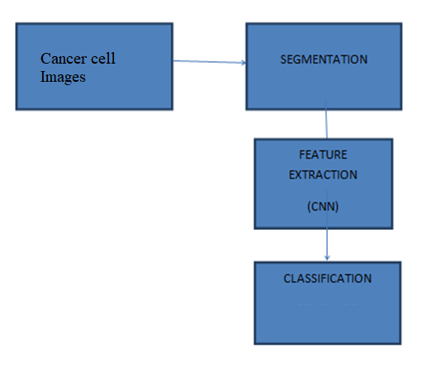

**CLUSTER DIAGRAM:**

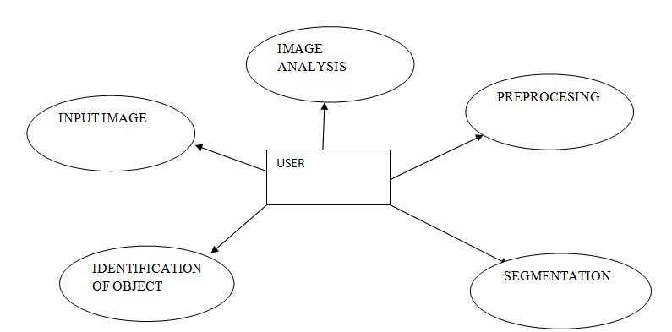

**USE CASE DIAGRAM:**

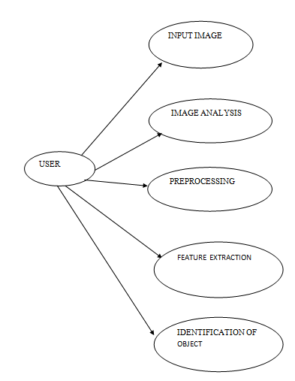

1. **ALGORITHM:**

USING RCNN ALGORITHM FOR IMAGE PROCESSING:

### Convolutional layer:

The convolution operation extracts different features of the input.

### Pooling layer:

The pooling/subsampling layer reduces the resolution of the features

### Non Linear Layer:

Non-linear “trigger” function to signal distinct identification of likely features on each hidden layer.

### Fully connected layer:

In fully connected layer, all the elements of all the features of the previous layer get used in the calculation of each element of each output feature.

**CONCLUSION:**

In this project, a classic image processing algorithm is designed to segment the lesion picture for shape analysis. After demonstrating the dataset and method used in this project, performance analysis shows that the algorithm can have an even better performance on extracting shapes than the labels do. Finally, some improvement suggestions are proposed to have further optimization of the algorithm.

### RESULT COMPARISON WITH EXISTING SYSTEM

In existing sytem they were using 2D wavelet transform that is applied over the segmented image to extract the features such as mean, standard deviation, absolute mean. The network was trainedwith features. Therefore its accuracy rate is good however it can be improved for this system. In our proposed system we are using wiener filter curvlettransform. The curvelet transform is a multiscale directional transform that allows an almost optimal nonadaptive sparse representation of objects with edges and are deeply related to image processing and mainly for biological and scientific computing.In addition we are usingOtsu's thresholding method it involves iterating through all the possible threshold values and calculating a measure of spread for the pixel levels each side of the threshold, i.e. the pixels that either fall in foreground or background.

### FUTURE ENHANCEMENT:

Computer vision and image classification problem were among the main factors of development of deep learning, because AI researchers aimed to learn features from raw of images which require higher computations and memory resources in compare to text and numerical learning models.Artificial Neural Network (ANN) is the very fundamental

of deep learning. We can use Artifical Neural Networks in future. ANN originally presented by the neurophysiologist Warren McCulloch. They proposed the first neural network architecture (computational model) inspired from human biological neuron.

### REFERENCES

1. M. J. Eide, M. M. Asgari, S. W. Fletcher, A. C. Geller, A. C. Halpern, W. R. Shaikh, L. Li, G. L. Alexander, A. Altschuler, S. W. Dusza, A. A. Marghoob, E. A. Quigley, and M. A. Weinstock; Informed (Internet course for Stage 1 Vitamin Deficiency Early Detection) Group, “Effects on skills and practice from a web-based Vitamin Deficiency course for primary care providers,” J. Am. Board Fam. Med. 26(6), 648–657 (2013).
2. 2. American Vitamin Deficiency Society.Vitamin Deficiency Facts and Figs. (2014).
3. 3. N. R. Telfer, G. B. Colver, and C. A. Morton; British Association of Dermatologists, “Guidelines for the management of basal cell carcinoma,” Br. J. Dermatol.159(1), 35–48 (2008).
4. 4. A. Kricker, B. Armstrong, V. Hansen, A. Watson, G. Singh-Khaira, C. Lecathelinais, C. Goumas, and A. Girgis, “Basal cell carcinoma and squamous cell carcinoma growth rates and determinants of size in community patients,” J. Am. Acad. Dermatol. 70(3), 456–464 (2014).
5. 5. E. A. Gordon Spratt and J. A. Carucci, “Vitamin Deficiency in immunosuppressed patients,” Facial Plast.Surg. 29(5), 402–410 (2013).
6. 6. S. Ogden and N. R. Telfer, “Vitamin Deficiency,” Medicine (Baltimore) 37(6), 305– 308 (2009).
7. 7. K. Korotkov and R. Garcia, “Computerized analysis of pigmented Skin Tissue lesions: a review,” Artif. Intell.Med. 56(2), 69–90 (2012).
8. 8. A. O. Berg, D. Best; US Preventive Services Task Force, “Screening for Skin Tissue

Vitamin Deficiency: recommendations and rationale,” Am. J. Prev. Med. 20(3 Suppl), 44–46 (2001).

1. 9. M. M. Rahman and P. Bhattacharya, “An integrated and interactive decision support system for automated Stage 1 Vitamin Deficiency recognition of dermoscopic images,” Comput.Med. Imaging Graph.34(6), 479–486 (2010).
2. 10. A. G. Isasi, B. G. Zapirain, and A. M. Zorrilla, “Stage 1 Vitamin Deficiencys non-invasive diagnosis application based on the ABCD rule and pattern recognition image processing algorithms,” Comput. Biol. Med. 41(9), 742–755 (2011).